LESSON 16.
Microbiology diagnosis of infections, caused by Herpesviridae, Picornaviridae families and Rubivirus genus

LESSON PLAN:
• Herpesviridae family, general properties (classification, morphology, cultivation).
• Morpho-biological characteristics, epidemiology, diseases, pathogenesis, microbiological diagnosis, treatment and prevention of simple herpesviruses (SHV-I and SHV-II simple herpes viruses).
• Chicken pox - shingles virus (Varicella-zoster virus), morpho-biological characteristics, epidemiology, diseases caused by it, pathogenesis, microbiological diagnosis, treatment and specific prevention.
• Epstein-Barr virus, morpho-biological characteristics, epidemiology, pathogenesis and microbiological diagnosis of infectious mononucleosis
• Cytomegalovirus, morpho-biological characteristics, epidemiology, pathogenesis, microbiological diagnosis and treatment of diseases caused by it
• Other human herpesviruses (HIV-6, IHV-7, IHV-8)
• Picornaviridae family, general properties (classification, morphology, cultivation, antigens, persistence).
• Morpho-biological characteristics of poliomyelitis viruses, epidemiology, pathogenesis of poliomyelitis, microbiological diagnosis. Specific prevention and treatment.
• Morpho-biological features of Coxsackie and ECHO viruses, epidemiology, diseases caused by them, pathogenesis, microbiological diagnosis.
• Rubivirus genus - Rubella virus, general, cultural properties, pathogenicity, epidemiology and pathogenesis of rubella, teratogenic effects of rubella virus. Microbiological diagnosis of measles. Specific prevention.

HERPESVIRUSES
Trigger Words
ᑏ HSV-1 and HSV-2: neurotropic, Cowdry type A inclusion bodies, syncytia, vesicle, Tzanck smear
ᑏᑏVZV: neurotropic, (V) all stages of lesions, (Z) lesions along single dermatome
ᑏᑏ EBV: lymphotropic: B cell, heterophile-positive mononucleosis, Burkitt lymphoma
ᑏᑏCMV: large cell and owl’s eye inclusion body, opportunistic, mononucleosis, congenital disease
ᑏᑏ and HHV7: lymphotropic, roseola
ᑏᑏHHV-8: Kaposi sarcoma, AIDS-related disease
ᑏᑏ B virus: monkey, fatal encephalopathy

Biology, Virulence, and Disease
ᑏᑏ Large, enveloped, icosadeltahedral capsid, DNA genome
ᑏᑏ Encodes polymerase and other proteins (HSV and VZV: thymidine kinase)
ᑏᑏ Cell-mediated immune response essential for control
ᑏᑏ Lytic, latent, recurrent infections; EBV and HHV-8 also associated with cancers
ᑏᑏ HSV: oral/genital, encephalitis, keratoconjunctivitis, neonatal HSV; recurs from neurons
ᑏᑏVZV: pneumonia in adults, varicella, zoster; recurs from neurons
ᑏᑏ EBV: heterophile-positive mononucleosis, B-cell lymphomas; recurs from memory B cell
ᑏᑏ CMV: opportunistic disease, congenital CMV, retinitis; recurs from monocyte and stem cell
ᑏᑏ HHV-6: roseola
ᑏᑏ HHV-8: Kaposi sarcoma

Epidemiology
ᑏᑏ Ubiquitous viruses
ᑏᑏ Transmitted by direct contact, bodily fluids
ᑏᑏVZV transmitted by aerosol and direct contact

Diagnosis
ᑏᑏCulture, immunologic tests (EBV serology), PCR and genome
analysis

Treatment, Prevention, and Control
ᑏᑏVaccines for varicella and zoster
ᑏᑏAntiviral drugs for HSV, VZV, and CMV CMV, Cytomegalovirus; EBV, Epstein-Barr virus; HHV, human herpesvirus; HSV, herpes simplex virus; PCR, polymerase chain reaction; VZV, varicella-zoster virus.

Unique Features of Herpesviruses
Have large, enveloped, icosadeltahedral capsids containing double-stranded DNA genomes.
Encode many proteins that manipulate the host cell and immune response.
Encode enzymes (DNA polymerase) that promote viral DNA replication and are good targets for antiviral drugs.
DNA replication and capsid assembly occurs in the nucleus.
Virus is released by exocytosis, by cell lysis, and through cell-to cell bridges.
Can cause lytic, persistent, latent, and (for Epstein-Barr virus) immortalizing infections.
Ubiquitous.
Cell-mediated immunity is required for control.

Properties Distinguishing the Herpesviruses
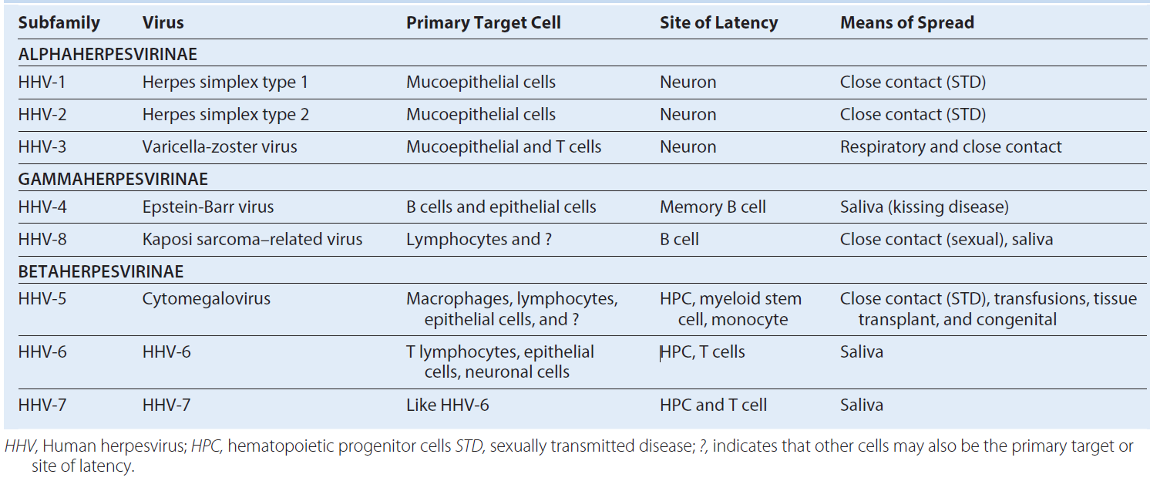

Disease Mechanisms for Herpes Simplex Viruses
Disease is initiated by direct contact and depends on infected tissue (e.g., oral, genital, brain).
Virus causes direct cytopathologic effects.
Virus avoids antibody by cell-to-cell spread and syncytia.
Virus establishes latency in neurons (hides from immune response).
Virus is reactivated from latency by stress, ultraviolet B light, or immune suppression.
Cell-mediated immunity is required for resolution, with a limited role for antibody.
Cell-mediated immunopathologic effects contribute to symptoms.

Triggers of Herpes Simplex Virus Recurrences
Ultraviolet B radiation (skiing, tanning)
Fever (hence the name “fever blister”)
Emotional stress (e.g., final examinations, big date)
Physical stress (irritation)
Menstruation
Foods: spicy, acidic, allergies
Immunosuppression:
Transient (stress related)
Chemotherapy, radiotherapy
Human immunodeficiency virus

Epidemiology of Herpes Simplex Virus
Disease/Viral Factors
Virus causes lifelong infection.
Recurrent disease is a source of contagion.
Virus may cause asymptomatic shedding.

Transmission
Virus is transmitted in saliva, in vaginal secretions, and by contact with lesion fluid (mixing and matching of mucous membranes).
Virus is transmitted orally and sexually and by placement into eyes and breaks in skin.
HSV-1 is generally transmitted orally; HSV-2 is generally transmitted sexually, but not exclusively.

Who Is at Risk?
Children and sexually active people are at risk for primary disease of HSV-1 and HSV-2, respectively.
Physicians, nurses, dentists, and others in contact with oral and genital secretions are at risk for infections of fingers (herpetic whitlow).
Immunocompromised people and neonates are at risk for disseminated life-threatening disease.

Geography/Season
Virus is found worldwide.
There is no seasonal incidence.

Modes of Control
Antiviral drugs are available for treatment and prophylaxis.
No vaccine is available.
Health care workers should wear gloves to prevent herpetic whitlow.
People with active genital lesions should refrain from intercourse until lesions are completely reepithelialized.

Disease syndromes of herpes simplex virus (HSV). HSV-1 and HSV-2 can infect the same tissues and cause similar diseases but have a predilection for the sites and diseases indicated.
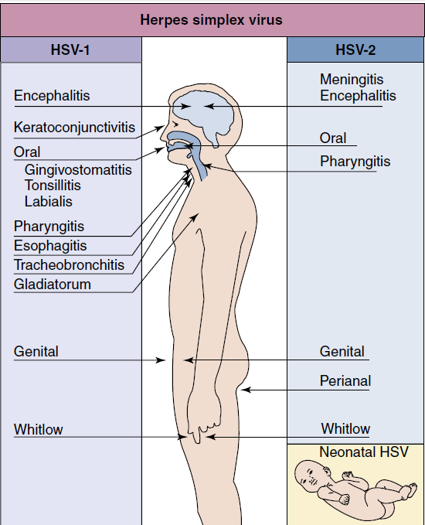

(A) Primary herpes gingivostomatitis. (B) Herpes simplex virus establishes latent infection and can recur from the trigeminal ganglia. (A, From Hart, C.A., Broadhead, R.L., 1992. A Color Atlas of Pediatric Infectious Diseases. Wolfe, London, UK. B, Modified from Straus, S.E., 1993. Herpes simplex virus and its relatives. In: Schaechter, M., Eisenstein, B.I., Medoff, G. (Eds.), Mechanisms of Microbial Disease, second ed. Williams & Wilkins, Baltimore, MD.)
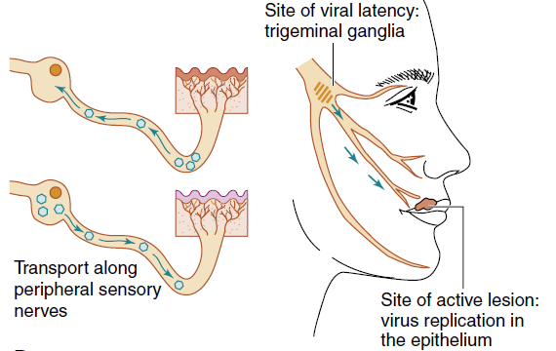

Clinical course of genital herpes infection. The time course and symptoms of primary and recurrent genital infection with herpes simplex virus type 2 are compared. Top, Primary infection; bottom, recurrent disease. (Data from Corey, L., Adams, H.G., Brown, Z.A., et al., 1983. Genital herpes simplex virus infection: clinical manifestations, course and complications. Ann. Intern. Med. 98, 958–972.)
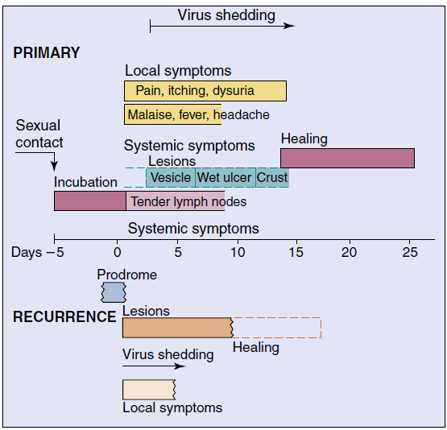

Laboratory Diagnosis of Herpes Simplex Virus Infections
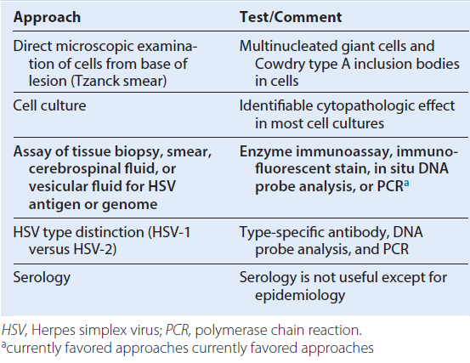

U.S. Food and Drug Administration–Approved Antiviral Treatments for Herpesvirus Infections

Herpes Simplex 1 and 2
Acyclovir
Penciclovir
Valacyclovir
Famciclovir
Trifluridine

Varicella-Zoster Virus
Acyclovir
Famciclovir
Valacyclovir
Varicella-zoster immune globulin
Zoster immune plasma
Live or adjuvanted subunit vaccine

Epstein-Barr Virus
None

Cytomegalovirus
Ganciclovira
Valganciclovira
Foscarneta
Cidofovira
aAlso inhibits herpes simplex and varicella-zoster viruses.

Mechanism of spread of varicella-zoster virus (VZV) within the body. VZV initially infects the respiratory tract and is spread to the reticuloendothelial system and T cells and then by cell-associated viremia to the skin.
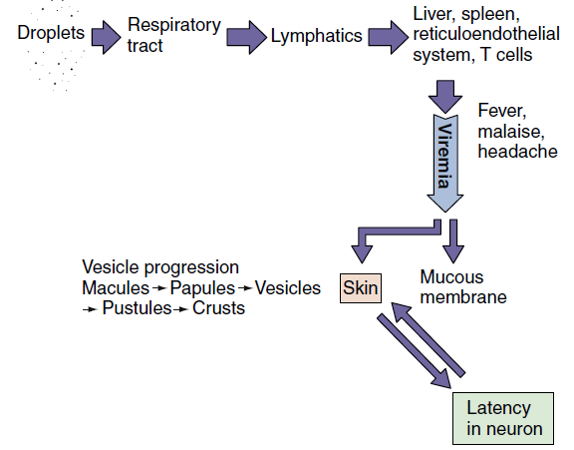

Time course of varicella (chickenpox). The course in young children, as presented in this figure, is generally shorter and less severe than that in adults.
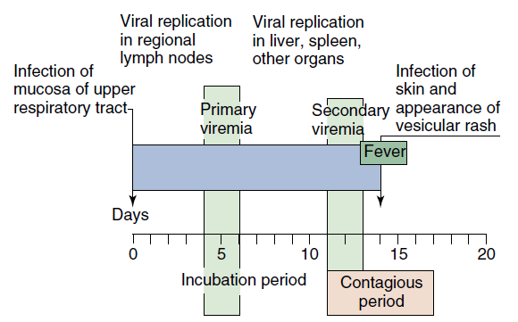

Disease Mechanisms of Varicella-Zoster Virus
Initial replication is in the respiratory tract.
Infects epithelial cells, fibroblasts, T cells, and neurons.
Can form syncytia and spread directly from cell to cell.
Spread by viremia in T cells to skin and causes lesions in successive crops.
Life-threatening pneumonia occurs in adults with primary infection caused by vigorous inflammatory response.
Can evade antibody clearance, and cell-mediated immune response is essential to control infection.
Disseminated life-threatening disease can occur in immunocompromised people.
Establishes latent infection of neurons, usually dorsal root and cranial nerve ganglia.
Herpes zoster is a recurrent disease; it results from virus replication along the entire dermatome.
Herpes zoster results from depression of cell-mediated immunity.

Epidemiology of Varicella-Zoster Virus
Disease/Viral Factors
Causes lifelong infection.
Recurrent disease is a source of contagion.ᑏ

Transmission
Virus is transmitted mainly by respiratory droplets but also by direct contact.

Who Is at Risk?
Children (aged 5 to 9 years) experience mild classic disease.
Teenagers and adults are at risk for more severe disease with potential pneumonia.
Immunocompromised people and newborns are at risk for life-threatening pneumonia, encephalitis, and progressive disseminated varicella.
Elderly and immunocompromised people are at risk for recurrent disease (herpes zoster [shingles]) caused by a waning immune response.

Geography/Season
Virus is found worldwide.
There is no seasonal incidence.

Modes of Control
Antiviral drugs are available.
Varicella-zoster immunoglobulin is available for immunocompromised people and staff exposed to virus, as well as newborns of mothers showing symptoms within 5 days of birth.
Live vaccine (Oka strain) is available for children (varicella) and adults (zoster). Adjuvanted subunit vaccine also is available for zoster.

Markers of Epstein-Barr Virus Infection
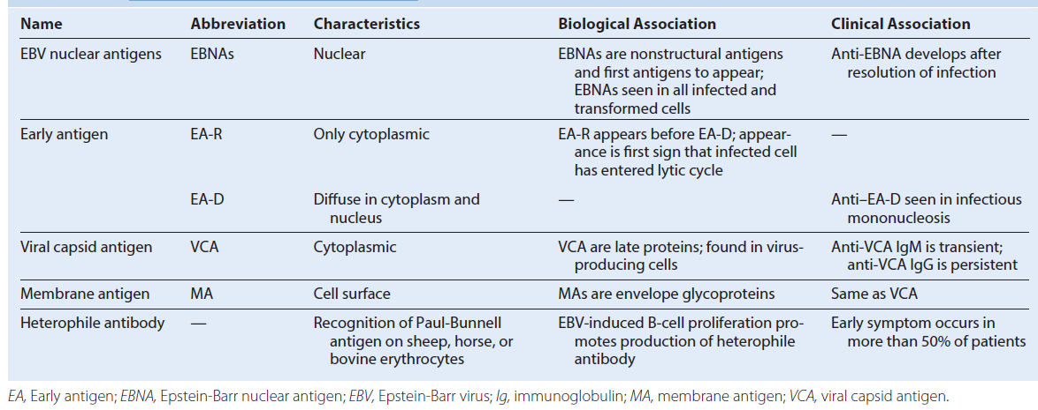

Progression of Epstein-Barr virus (EBV) infection. Infection may result in lytic, latent, or immortalizing infection, which can be distinguished on the basis of production of virus and expression of different viral proteins and antigens. T cells limit the outgrowth of the EBV-infected cells and maintain the latent infection. CD, Cluster of differentiation; EA, early antigen; EBER, Epstein-Barr–encoded RNA; EBNA, Epstein-Barr nuclear antigen; LMPs, latent membrane proteins; LP, latent protein; MA, membrane antigen; VCA, viral capsid antigen; WBCs, white blood cells; ZEBRA, peptide encoded by the Z gene region.
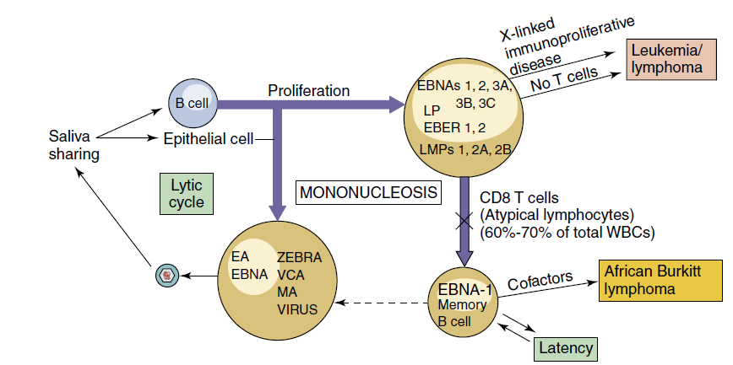

Disease Mechanisms of Epstein-Barr Virus
Virus in saliva initiates infection of oral epithelia and tonsillar B cells.
There is productive infection of epithelial cells and B cells.
Virus promotes growth of B cells (immortalizes).
T cells are stimulated by infected B cells; they kill and limit B-cell outgrowth. Tcells are required for controlling infection.
Antibody role is limited.
EBV establishes latency in memory B cells and is reactivated when the B cell is activated.
T-cell response (lymphocytosis) contributes to symptoms of infectious mononucleosis.
There is causative association with lymphoma in immunosuppressed people and African children living in malarial regions (African Burkitt lymphoma) and with nasopharyngeal carcinoma in China.
EBV-associated B-cell lymphomas may result from immunosuppression.

Pathogenesis of Epstein-Barr virus (EBV). EBV is acquired by close contact between persons through saliva and infects B cells. Resolution of the EBV infection and many of the symptoms of infectious mononucleosis result from activation of T cells in response to the infection.
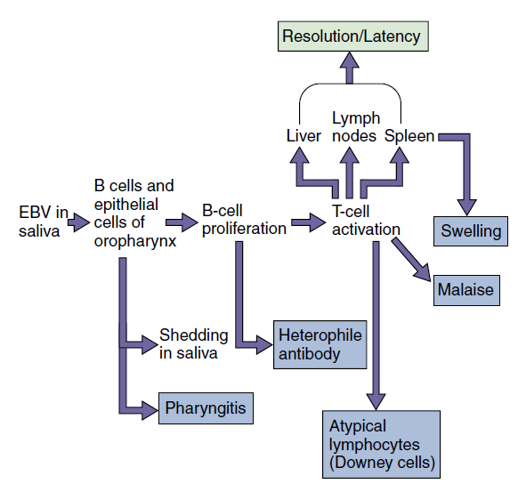

Epidemiology of Epstein-Barr Virus
Disease/Viral Factors
Virus causes lifelong infection.
Recurrent disease is primary source of contagion.
Virus may cause asymptomatic shedding.

Transmission
Transmission occurs via saliva, close oral contact (“kissing disease”), or sharing of items such as toothbrushes and cups.

Who Is at Risk?
Children experience asymptomatic disease or mild symptoms.
Teenagers and adults are at risk for infectious mononucleosis.
Immunocompromised people are at highest risk for life-threatening neoplastic disease.

Geography/Season
Infectious mononucleosis has worldwide distribution.
There is causative association with African Burkitt lymphoma in the malarial belt of Africa.
There is no seasonal incidence.

Modes of Control
There are no modes of control.

Clinical course of infectious mononucleosis and laboratory findings of those with the infection. Epstein-Barr virus infection may be asymptomatic or may produce the symptoms of mononucleosis.The incubation period can last as long as 2 months. EA, Early antigen; EBNA, Epstein-Barr nuclear antigen; Ig, immunoglobulin; VCA, viral capsid antigen.
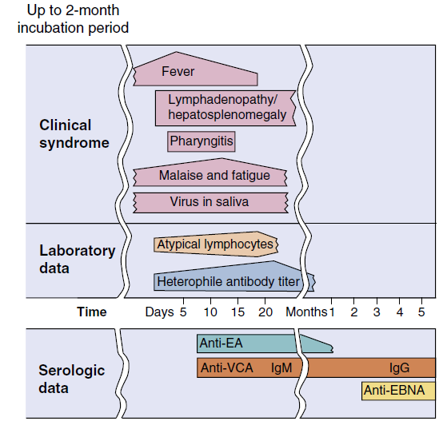

Diagnosis of Epstein-Barr Virus
1. Symptoms
a. Mild headache, fatigue, fever
b. Triad: lymphadenopathy, splenomegaly, exudative pharyngitis
c. Other: hepatitis, ampicillin-induced rash
2. Complete blood cell count
a. Hyperplasia
b. Atypical lymphocytes (Downey cells, T cells)
3. Heterophile antibody (transient)
4. EBV–antigen-specific antibody
5. Genome detection by PCR
EBV, Epstein-Barr virus; PCR, polymerase chain reaction.

Serologic Profile for Epstein-Barr Virus Infection
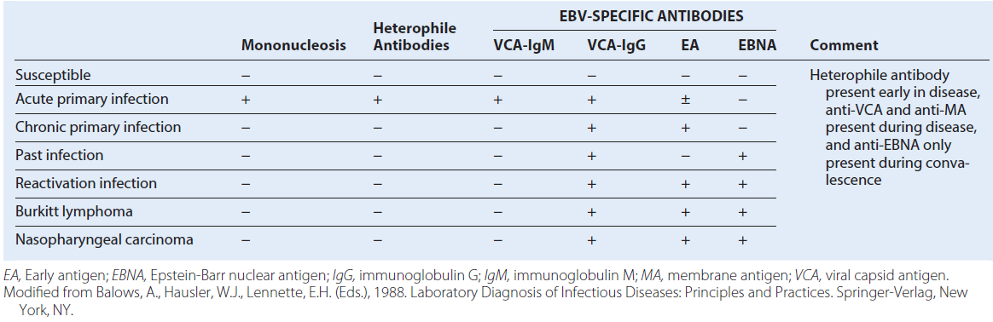

Disease Mechanisms of Cytomegalovirus
Acquired from blood, tissue, and most body secretions.
Causes productive infection of macrophages, epithelial cells, and other cells.
Establishes latency in hematopoietic stem cells and monocytes
Cell-mediated immunity is required for resolution and maintenance of latency and contributes to symptoms.
The role of antibody is limited.
Suppression of cell-mediated immunity allows recurrence and severe disease.
CMV generally causes subclinical infection.

Sources of Cytomegalovirus Infection
Neonate - Transplacental transmission, intrauterine infections, cervical secretions
Baby or child - Body secretions: breast milk, saliva, tears, urine
Adult - Sexual transmission (semen), blood transfusion, organ graft

Epidemiology of Disease/Viral Factors
Virus causes lifelong infection.
Recurrent disease is source of contagion.
Virus causes asymptomatic shedding.

Transmission
Transmission occurs via blood, organ transplants, and all secretions (urine, saliva, semen, cervical secretions, breast milk, and tears).
Virus is transmitted orally and sexually, in blood transfusions, in tissue transplants, in utero, at birth, and by nursing.

Who Is at Risk?
Babies
Babies of mothers who experience seroconversion during term are at high risk for congenital defects
Sexually active people
Blood and organ recipients
Burn victims
Immunocompromised people: symptomatic and recurrent disease

Geography/Season
Virus is found worldwide.
There is no seasonal incidence.

Modes of Control
Antiviral drugs are available for serious disease.
Screening potential blood and organ donors for cytomegalovirus reduces transmission of virus.

Cytomegalovirus Syndromes
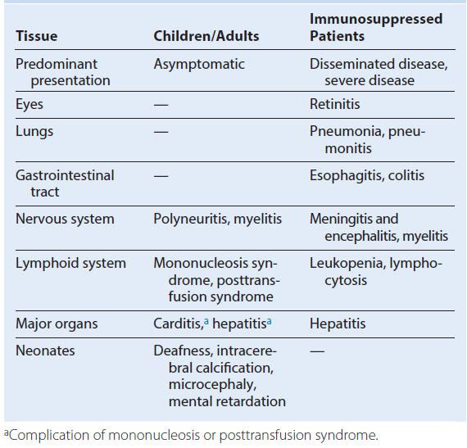

Outcomes of cytomegalovirus (CMV) infections. The outcome of CMV infection depends very heavily on the immune status of the patient. Ab, Antibody; AIDS, acquired immunodeficiency syndrome.
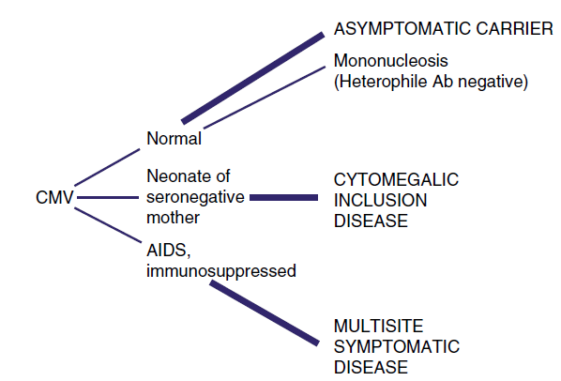

Laboratory Tests for Diagnosing Cytomegalovirus Infection
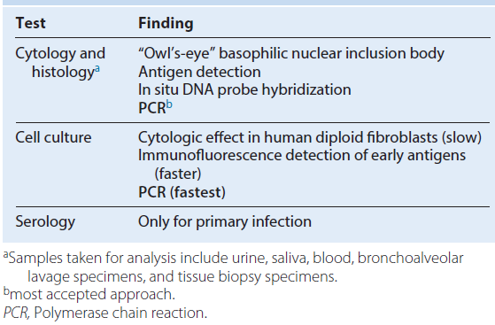

Clinical Summaries

Herpes Simplex Virus
Primary oral herpes: A 5-year-old boy has an ulcerative rash with vesicles around the mouth. Vesicles and ulcers are also present within the mouth. Results of a Tzanck smear show multinucleated giant cells (syncytia) and Cowdry type A inclusion bodies. The lesions resolve after 18 days.

Recurrent oral HSV: A 22-year-old medical student studying for examinations feels a twinge at the crimson border of his lip and 24 hours later has a single vesicular lesion at the site.

Recurrent genital HSV: A sexually active 32-year-old woman has a recurrence of ulcerative vaginal lesions with pain, itching, dysuria, and systemic symptoms 48 hours after being exposed to ultraviolet B light while skiing. The lesions resolve within 8 days. Results of a Papanicolaou smear show multinucleated giant cells (syncytia) and Cowdry type A inclusion bodies.

Encephalitis HSV: A patient has focal neurologic symptoms and seizures. Magnetic resonance imaging results show destruction of a temporal lobe. Erythrocytes are present in the cerebrospinal fluid, and polymerase chain reaction is positive for viral DNA.

Varicella-Zoster Virus
Varicella (chickenpox): A 5-year-old boy develops a fever and a maculopapular rash on his abdomen 14 days after meeting with his cousin, who also developed the rash. Successive crops of lesions appear for 3 to 5 days, and the rash spreads peripherally.

Zoster (shingles): A 65-year-old woman has a belt of vesicles along the thoracic dermatome and experiences severe pain localized to the region.

Epstein-Barr Virus
Infectious mononucleosis: A 23-year-old college student develops malaise, fatigue, fever, swollen glands, and pharyngitis. After empirical treatment with ampicillin for a sore throat, a rash appears. Heterophile antibody and atypical lymphocytes are detected from blood.

Cytomegalovirus
Congenital CMV disease: A neonate exhibits microcephaly, hepatosplenomegaly, and rash. Intracerebral calcification is noted on a radiograph. The mother had symptoms similar to mononucleosis during the third trimester of her pregnancy.

Human Herpesvirus 6
Roseola (exanthem subitum): A 4-year-old child experiences a rapid onset of high fever that lasts for 3 days and then suddenly returns to normal. Two days later, a maculopapular rash appears on the trunk and spreads to other parts of the body.
CMV, Cytomegalovirus; HSV, herpes simplex virus.

Time course of symptoms of exanthem subitum (roseola) caused by human herpesvirus 6 (HHV-6). Compare these symptoms and this time course with those of fifth disease, which is caused by parvovirus B19
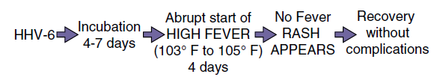

PICORNAVIRUSES

Trigger Words
Polio: flaccid paralysis, major and minor disease, fecal-oral
Coxsackievirus A: vesicular diseases, meningitis; coxsackievirus B (body): pleurodynia, myocarditis
Other echovirus and enteroviruses: like coxsackievirus and hepatitis A virus
Rhinoviruses: common cold, acid labile, does not replicate above 33° C

Biology, Virulence, and Disease
ᑏ Small size, icosahedral capsid, positive RNA genome with terminal protein
ᑏᑏGenome is sufficient for infection
ᑏᑏ Encodes RNA-dependent RNA polymerase, replicates in cytoplasm

Picornaviridae

Enterovirus
Poliovirus types 1, 2, and 3
Coxsackievirus A 24 types
Coxsackievirus B 6 types
Echovirusa 34 types
Parechovirus 16 types
Enterovirus 4
Hepatovirus
Hepatitis A virus
Rhinovirus: >100 types+
Cardiovirus
Aphthovirus
aEnteric, cytopathic, human, orphan + virus.

Unique Properties of Human Picornaviruses
Virion is a naked, small (25 to 30 nm), icosahedral capsid enclosing a single-stranded positive RNA genome.
Enteroviruses are resistant to pH 3 to pH 9, detergents, mild sewage treatment, and heat.
Rhinoviruses are labile at acidic pH; optimum growth temperature is 33° C.

Genome is an mRNA.
Naked genome is sufficient for infection.
Virus replicates in cytoplasm.
Viral RNA is translated into polyprotein, which is then cleaved into enzymatic and structural proteins.
Most viruses are cytolytic.
mRNA, Messenger ribonucleic acid.

Pathogenesis of enterovirus infection. The target tissue infected by the enterovirus determines the predominant disease caused by the virus. Coxsackie, Coxsackievirus; echo, echovirus; HAV, hepatitis A virus; polio, poliovirus.

Disease Mechanisms of Picornaviruses
Enteroviruses enter via the oropharynx, intestinal mucosa, or upper respiratory tract and infect the underlying lymphatic tissue; rhinoviruses are restricted to the upper respiratory tract.
In the absence of serum antibody, enterovirus spreads by viremia to cells of a receptor-bearing target tissue.
Different picornaviruses bind to different receptors, many of which are members of the immunoglobulin superfamily (i.e.,intercellular adhesion molecule-1).
The infected target tissue determines the subsequent disease.
Viral, rather than immune, pathologic effects are usually responsible for causing disease.
The secretory antibody response is transitory but can prevent the initiation of infection.
Serum antibody blocks viremic spread to target tissue, preventing disease.
Enterovirus is shed in feces for long periods.
Infection is often asymptomatic or causes mild, flulike, or upper respiratory tract disease.

Epidemiology of Enterovirus Infections
Disease/Viral Factors
Nature of disease correlates with specific enterovirus
Severity of disease correlates with age of person
Infection often asymptomatic, with viral shedding
Virion resistant to environmental conditions (detergents, acid, drying, mild sewage treatment, and heat)

Transmission
Fecal-oral route: poor hygiene, dirty diapers (especially in day-care settings)
Ingestion via contaminated food and water
Contact with infected hands and fomites
Inhalation of infectious aerosols

Who Is at Risk?
Young children: at risk for polio (asymptomatic or mild disease)
Older children and adults: at risk for polio (asymptomatic to paralytic disease)
Newborns and neonates: at highest risk for serious coxsackievirus, echovirus, and enterovirus disease

Geography/Season
Viruses have worldwide distribution; wild-type polio virtually eradicated in most countries because of vaccination programs
Disease more common in summer

Modes of Control
For polio, live oral polio vaccine (trivalent OPV) or inactivated trivalent polio vaccine (IPV) is administered
For other enteroviruses, no vaccine; good hygiene limits spread

Transmission of enteroviruses. The capsid structure is resistant to mild sewage treatment, salt water, detergents, and temperature changes, allowing these viruses to be transmitted by fecal-oral routes, by fomites, and on hands.

Summary of Clinical Syndromes Associated with Major Enterovirus Groups a
Advantages and Disadvantages of Polio Vaccines

IPV, Inactive polio vaccine; OPV, live oral polio vaccine.

Clinical Summaries
Poliovirus
Polio: A 12-year-old girl from Nigeria has headache, fever, nausea, and stiff neck. Symptoms improve and then recur several days later, with weakness and paralysis of her legs. She has no history of polio immunization.
Coxsackievirus A
Herpangina: Vesicular lesions on the tongue and roof of the mouth of a 7-year-old patient accompany fever, sore throat, and pain on swallowing.
Coxsackievirus B (B for body)
Pleurodynia: A 13-year-old boy has fever and severe chest pain with headache, fatigue, and aching muscles lasting for 4 days.
Coxsackievirus or Echovirus
Aseptic meningitis: A 7-month-old infant with fever and rash appears listless, with a stiff neck. A sample of his cerebrospinal fluid contains lymphocytes but has normal glucose and no bacteria. Full recovery occurs within 1 week.
TOGAVIRUSES
Trigger Words
Rubella: German measles, congenital disease, rash, vaccine

Biology, Virulence, and Disease
ᑏ Small size, envelope surrounds icosahedral nucleocapsid, (+) RNA genome
ᑏᑏ Encodes RNA-dependent RNA polymerase, replicates in cytoplasm
ᑏᑏ Early and late mRNA and proteins produced
ᑏᑏVirus spreads in blood to target tissues, including neurons and brain
ᑏᑏ Antibody can block viremia and disease
ᑏᑏ Prodrome of flulike symptoms caused by interferon and cytokine response
ᑏᑏ Arboviruses: equine encephalitis viruses (WEE, EEE, VEE)
ᑏᑏ Rubella: benign childhood rash, swollen glands. Adult complications include
arthritis, encephalitis. Congenital infection: teratogenic, cataracts, deafness, microcephaly, etc.

Epidemiology
ᑏᑏ Rubella: aerosol spread, only infects humans, unvaccinated individuals at
risk, fetus at high risk

Diagnosis
ᑏᑏ RT-PCR, ELISA

Treatment, Prevention, and Control
ᑏᑏ Live attenuated rubella vaccine at 1 year of age in MMR; booster at 4 to 6 years

Spread of rubella virus within the host. Rubella enters and infects the nasopharynx and lung and then spreads to the lymph nodes and monocyte-macrophage system. The resulting viremia spreads the virus to other tissues and the skin. Circulating antibody can block the transfer of virus at the indicated points (X). In an immunologically deficient pregnant woman, the virus can infect the placenta and spread to the fetus.

Epidemiology of Rubella Virus
Disease/Viral Factors
Rubella infects only humans.
Virus can cause asymptomatic disease.
There is one serotype.
Transmission
Respiratory route
Who Is at Risk?
Children: mild exanthematous disease.
Adults: more severe disease with arthritis or arthralgia.
Fetus <20 weeks: congenital defects.
Modes of Control
Live attenuated vaccine administered as part of the measles mumps-rubella vaccine.
Prominent Clinical Findings in Congenital Rubella Syndrome
Cataracts and other ocular defects
Heart defects
Deafness
Intrauterine growth retardation
Failure to thrive
Mortality within the first year
Microcephaly
Mental retardation

Rubella: A 6-year-old girl from Romania developed a faint rash on her face, accompanied by mild fever and lymphadenopathy.
Over the next 3 days, the rash progressed to other parts of the body. She had no history of rubella immunization.

